PP Stone

**Extro Short Body Bib Cock (Blue & White)**

**Product Description:**

The Extro Short Body Bib Cock features a compact and colorful design that blends utility with style, ideal for wash basins, utility sinks, and compact wall installations.

**5 Key Features (Single Line):**

1. Space-saving short body design for easy wall installation,
2. Durable PTMT plastic ensures rust-free, long-term performance,
3. Stylish blue & white finish for a modern aesthetic,
4. Smooth single lever operation with easy quarter turn,
5. Versatile use in bathrooms, kitchens, and garden outlets.

**Product Specification:**

* **Brand:** Extro
* **Model:** Short Body Bib Cock (Blue & White)
* **Material:** PTMT Plastic
* **Color:** White body with Blue Handle & Spout Cap
* **Finish:** Matte/Semi-Gloss
* **Installation Type:** Wall Mounted
* **Inlet Size:** ½ inch BSP Thread
* **Handle Type:** Single Lever
* **Operation:** Quarter Turn
* **Ideal Use:** Wash basins, kitchen sinks, garden taps, utility areas
* **Flow Type:** Standard aerated stream



**Extro Long Body Bib Cock (Blue & White)**

**Product Description:**

The Extro Long Body Bib Cock offers an extended outlet and ergonomic control, making it ideal for efficient water flow in utility areas, bathrooms, or kitchens with wall-mounted installation needs.

**5 Key Features (Single Line):**

1. Extended body design for better reach and clearance,
2. Made from durable PTMT plastic ensuring rust-free longevity,
3. Stylish blue and white finish enhances aesthetics,
4. Smooth quarter-turn lever for easy water control,
5. Wall flange included for a neat installation.

**Product Specification:**

* **Brand:** Extro
* **Model:** Long Body Bib Cock (Blue & White)
* **Material:** PTMT Plastic
* **Color:** Blue Handle and Flange, White Body
* **Finish:** Glossy
* **Installation Type:** Wall Mounted
* **Inlet Size:** ½ inch BSP Thread
* **Handle Type:** Single Lever
* **Operation:** Quarter Turn
* **Ideal For:** Bathrooms, kitchens, utility areas
* **Flow Type:** Regular stream

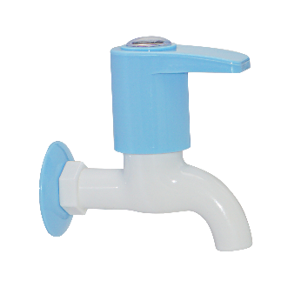

**Extro 2 in 1 Long Body Bib Cock (Blue & White)**

**Product Description:**

The Extro 2 in 1 Long Body Bib Cock is designed for dual utility, offering convenience, functionality, and modern aesthetics with its extended body and dual outlet design for both tap and washing machine or jet spray connection.

**5 Key Features (Single Line):**

1. Dual outlet for tap and attachment connectivity,
2. Durable PTMT plastic body ensures corrosion resistance,
3. Extended neck for better reach and usability,
4. Sleek blue and white finish enhances decor,
5. Wall flange included for clean installation.

**Product Specification:**

* **Brand:** Extro
* **Model:** 2 in 1 Long Body Bib Cock (Blue & White)
* **Material:** PTMT Plastic
* **Color:** Blue Handle and Flange, White Body
* **Finish:** Glossy
* **Installation Type:** Wall Mounted
* **Inlet Size:** ½ inch BSP Thread
* **Handle Type:** Single Lever
* **Operation:** Quarter Turn
* **Utility Ports:** 2 (Main outlet + Auxiliary nozzle)
* **Ideal For:** Bathrooms, utility spaces, washing machine connections

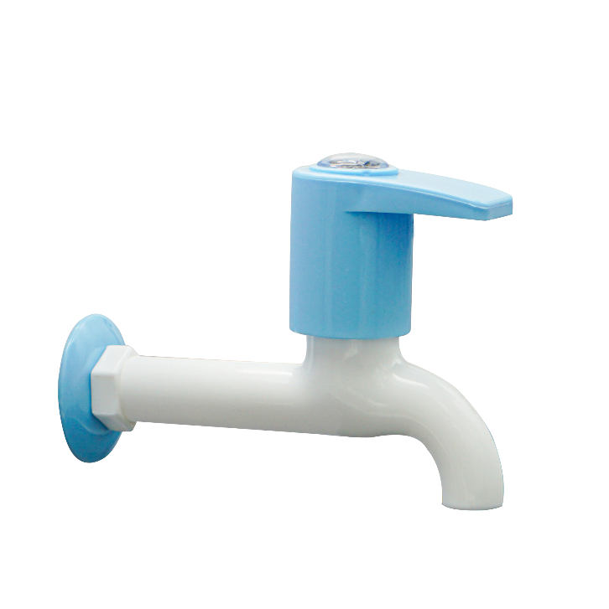

**Extro Nozzle Bib Cock (Blue & White)**

**Product Description:**

The Extro Nozzle Bib Cock is a premium water outlet solution featuring a hose-compatible nozzle, ideal for washing machine connections, garden hoses, or utility washing with a compact and durable design.

**5 Key Features (Single Line):**

1. Hose nozzle for direct pipe connection,
2. Strong PTMT body resists rust and scaling,
3. Smooth lever handle for easy operation,
4. Eye-catching blue and white aesthetic,
5. Comes with wall flange for clean installation.

**Product Specification:**

* **Brand:** Extro
* **Model:** Nozzle Bib Cock (Blue & White)
* **Material:** PTMT Plastic
* **Color:** Blue Handle, White Body
* **Finish:** Glossy
* **Installation Type:** Wall Mounted
* **Inlet Size:** ½ inch BSP Thread
* **Spout Type:** Hose Nozzle
* **Handle Type:** Quarter Turn Lever
* **Ideal For:** Garden, washing machine, utility sink connections

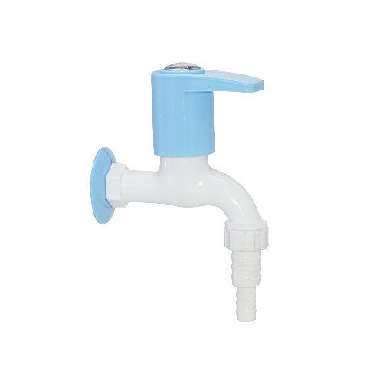

**Extro PTMT Sink Cock (Blue & White)**

**Product Description:**

The Extro PTMT Sink Cock is a deck-mounted, durable faucet designed for kitchen or basin use, offering smooth water flow and a stylish blue and white finish to enhance any modern sink area.

**5 Key Features (Single Line):**

1. Deck-mounted design for compact sink installation,
2. Made from high-quality PTMT for long life and rust resistance,
3. Smooth lever handle for effortless operation,
4. Elegant curved spout for optimal reach and splash control,
5. Blue and white finish adds a modern touch to interiors.

**Product Specification:**

* **Brand:** Extro
* **Model:** PTMT Sink Cock (Blue & White)
* **Material:** PTMT Plastic
* **Color:** Blue Handle, White Body
* **Finish:** Glossy
* **Mount Type:** Deck Mounted
* **Inlet Connection Size:** ½ inch BSP
* **Handle Type:** Quarter Turn Lever
* **Application:** Kitchen sink, wash basin
* **Flow Type:** Single Flow

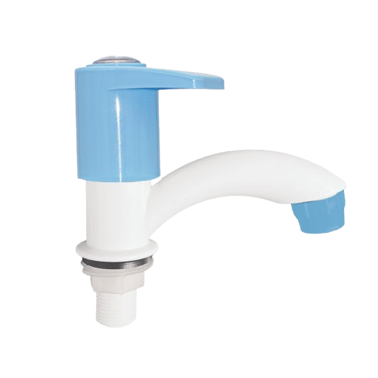

**Extro PTMT 2-in-1 Bib Cock with Wall Hook (Blue & White)**

**Product Description:**

The Extro PTMT 2-in-1 Bib Cock with Wall Hook combines dual functionality and space-saving design, ideal for connecting both a tap and hand shower or washing machine, while maintaining modern aesthetics in blue and white.

**5 Key Features (Single Line):**

1. Dual outlet design for versatile use,
2. High-quality PTMT construction ensures strength and durability,
3. Integrated wall hook for added utility and convenience,
4. Smooth lever handle for precise water flow control,
5. Stylish blue and white color enhances bathroom decor.

**Product Specification:**

* **Brand:** Extro
* **Model:** PTMT 2-in-1 Bib Cock with Hook
* **Material:** PTMT Plastic
* **Color:** Blue Handle, White Body
* **Finish:** Glossy
* **Mount Type:** Wall Mounted
* **Inlet Size:** ½ inch BSP
* **Outlets:** Dual (Tap + Shower/Washing Machine Connector)
* **Hook Type:** Integrated wall hook
* **Handle Operation:** Quarter Turn Lever
* **Applications:** Bathrooms, washing machine area, utility space

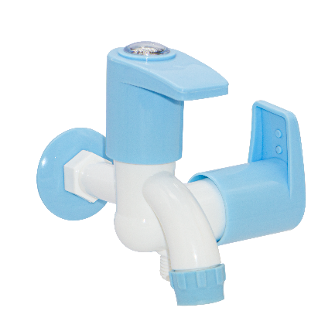

**Extro PTMT Angle 2-in-1 Faucet (Blue & White)**

**Product Description:**

The Extro PTMT Angle 2-in-1 Faucet is a versatile dual-control wall-mounted tap that combines angular utility with modern aesthetics, ideal for bathrooms and utility spaces requiring both tap and appliance connection.

**5 Key Features (Single Line):**

1. Dual-control lever for separate water lines,
2. Robust PTMT body for long-lasting durability,
3. Stylish angular design for modern interiors,
4. Leak-resistant internal mechanism,
5. Ideal for geyser or washing machine connection.

**Product Specification:**

* **Brand:** Extro
* **Model:** PTMT Angle 2-in-1 Faucet
* **Material:** PTMT (Polytetra Methylene Terephthalate)
* **Color:** Blue Handle with White Body
* **Mounting Type:** Wall Mounted
* **Operation Type:** Dual Quarter Turn Levers
* **Inlet Size:** ½ inch BSP
* **Outlets:** 2 (Tap + Appliance/Geyser connection)
* **Finish:** Glossy
* **Use Case:** Bathrooms, utility rooms, washing areas

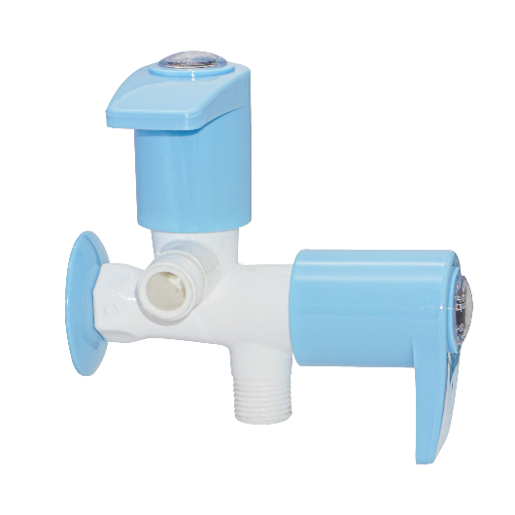

**Extro PTMT Angle Cock with Wall Flange (Blue & White)**

**Product Description:**

This Extro PTMT Angle Cock features a single-handle quarter-turn mechanism, ideal for use with flush tanks, geysers, or appliance water inlets, combining smooth performance and elegant design.

**5 Key Features (Single Line):**

1. Compact design ideal for appliance inlet or flush tank,
2. PTMT material ensures rust-free and leak-free durability,
3. Easy-to-operate quarter-turn lever,
4. Blue ergonomic handle with a smooth finish,
5. Wall flange included for neat and secure installation.

**Product Specification:**

* **Brand:** Extro
* **Model:** PTMT Angle Cock
* **Material:** PTMT (Polytetra Methylene Terephthalate)
* **Color:** Blue Handle with White Body
* **Mounting Type:** Wall Mounted
* **Operation Type:** Quarter Turn
* **Inlet Size:** ½ inch BSP
* **Outlet Type:** Male threaded (for connection to pipes, flush tanks, etc.)
* **Finish:** Glossy
* **Use Case:** Geysers, flush tanks, washing machines

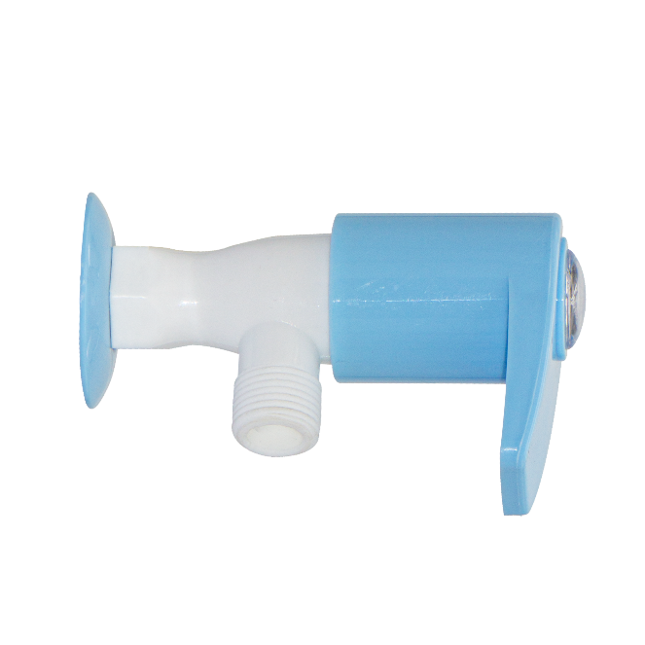

**xtro PTMT Swan Neck Wall Mounted Tap (Blue & White)**

**Product Description:**

The Extro PTMT Swan Neck Tap features a high-arc design for enhanced reach and easy use in kitchen sinks or utility areas. Crafted from high-quality PTMT material, it combines elegance with long-lasting durability.

**5 Key Features (Single Line):**

1. Elegant swan neck for extended reach and splash-free operation,
2. Durable PTMT construction with high resistance to corrosion,
3. Smooth quarter-turn handle for effortless flow control,
4. Attractive blue and white glossy finish,
5. Wall-mounted design with matching flange for clean installation.

**Product Specification:**

* **Brand:** Extro
* **Model:** PTMT Swan Neck Wall Tap
* **Material:** PTMT (Polytetra Methylene Terephthalate)
* **Color:** White Neck with Blue Handle
* **Mounting Type:** Wall Mounted
* **Operation Type:** Quarter Turn
* **Inlet Size:** ½ inch BSP
* **Spout Type:** Swan neck spout for wide coverage
* **Finish:** Smooth and Glossy
* **Application:** Kitchen sinks, utility washing areas, labs

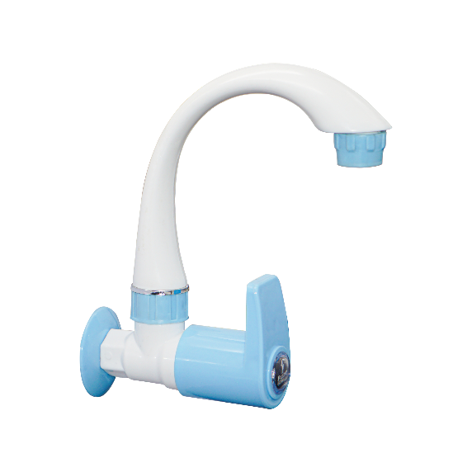

**Extro PTMT Swan Neck Pillar Tap (Blue & White)**

**Product Description:**

The Extro PTMT Swan Neck Pillar Tap offers a stylish and highly functional water control solution, ideal for kitchen sinks or basins. Featuring a high-arc swan neck spout, it ensures broad water coverage and splash-free usage with easy top handle operation.

**5 Key Features (Single Line):**

1. High-arc swan neck design for extended reach and smooth water flow,
2. Robust PTMT build with anti-corrosion properties,
3. Ergonomic quarter-turn handle for effortless control,
4. Stylish dual-tone finish for modern aesthetics,
5. Ideal for kitchen sinks and countertop basins.

**Product Specifications:**

* **Brand:** Extro
* **Model:** PTMT Swan Neck Pillar Tap
* **Material:** PTMT (Polytetra Methylene Terephthalate)
* **Color:** White Neck with Blue Handle
* **Mounting Type:** Pillar Mounted
* **Spout Type:** Swan Neck
* **Handle Type:** Quarter Turn Knob
* **Finish:** Glossy
* **Inlet Connection:** ½ inch BSP Thread
* **Application:** Kitchen Sink, Table-top Washbasins

